

FortnaPlus Control
Combined Jam Zones
Combined Jam Zones
Document Revision: 1.1
Date: 17 June 2020

Revision | Date | Author | Revision Summary
1.0 | 02-Nov-2008 | B Conklin | New document
1.1 | 17-Jun-2020 | T R Kremser | Updates and general refresh

Table of Contents
1.0 Combined Jam Zone Module Overview 4
2.0 Combined Jam Zone Menus 4
3.0 The CombinedJamZones Table 5
4.0 The CombinedEnableBits Table 6

Confidential/Proprietary Statement
This document contains trade secrets and information that is considered confidential and proprietary to Fortna, Inc. It may not be duplicated, used, or disclosed outside the original recipient organization, and it may not be duplicated, in whole or in part, for any purpose other than to evaluate this document. Fortna Material Handling reserves the right to modify this document as necessary to reflect any terms and conditions negotiated and included as part of a subsequent contract or purchase order.

Combined Jam Zone Module Overview
The Combined Jam Zone module is provided as a tool to combine multiple start/stop jam zones into one output signal. The software performs a logical “AND” on each of the selected bits and turns the selected output ON if all bits are ON. The module could be used for anything that requires a logical AND (or AND NOT) of multiple inputs to produce one output.

Combined Jam Zone Menus
The Combined Jam Zone module is configured using two tables that are found under Configuration Menu… -> Standard Controls -> Start Stop Util:

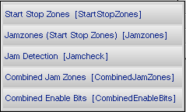

- Combined Jam Zones – The CombinedJamZones top-level table. This table defines each combined jam zone, and contains the output resulting from the combination.
- Combined Enable Bits – The CombinedEnableBits table contains all the individual input parts to be combined. Individual parts can be inverted here, as well, to improve flexibility.

The CombinedJamZones Table
The CombinedJamZones table is used to configure an output that will be turned ON or OFF based on the configuration of the input parts and the configuration of the output itself.

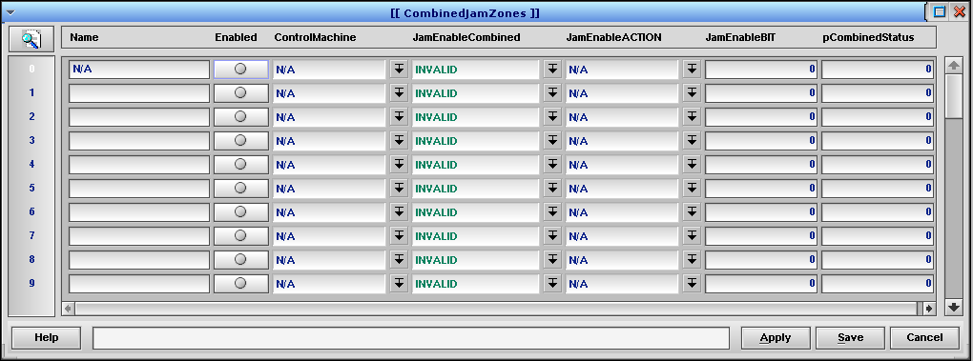

CombinedJamZones Table
Field | Type | Description
Name | String | Enter a descriptive name for the combined jam zone.
Enabled | Radio | Activate or deactivate the row. If the row is not enabled, the JamEnableCombined output will be set to OFF.
ControlMachine | PopUp | Choose the Machine that will control the output.
JamEnableCombined | PopUp | Choose the Conveyor Part that will be turned ON or OFF by the actions of this module.
JamEnableACTION | PopUp | Choose the way to control the JamEnableCombined part.
JamEnableBit | Int | If JamEnableAction is Enable or Disable, enter the bit number that will be used to accomplish that action.
pCombinedStatus | Int | Used by the module as it is determining the overall state of the combined jam zone.

The CombinedEnableBits Table
The CombinedEnableBits table defines the parts to be combined for a given CombinedJamZones entry. Each part is associated with a specific record in the CombinedJamZones table by selecting it in the CombinedJamZones Column.

For the CombinedJamZones_JamEnableCombined part to be ON, all the associated parts in JamEnableBit with InvertJamBit = N must be ON (Green), and all the associated parts with InvertJamBit = Y must be OFF (Red).

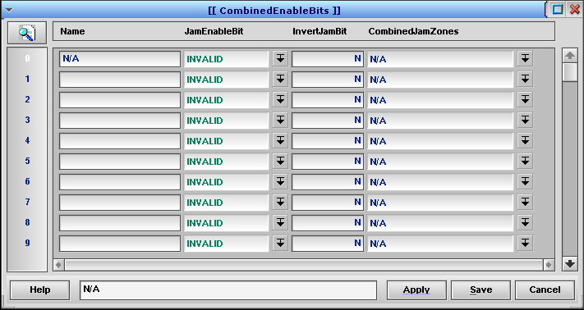

CombinedEnableBits Table
Field | Type | Value or Description
Name | String | Enter a descriptive name for the part
JamEnableBit | PopUp | Choose a part from the Conveyor table to include in the list of parts with states to combine. If all the parts for a given CombinedJamZone “pass” when the InvertJamBit setting is considered, the overall state will be ON (Green).
InvertJamBit | Y/N | Choose the “sense” to use when combining this part’s state. If this is set to N, the part’s state is used as-is. If this is set to Y, the part’s state is inverted before the comparison. So, for N, Green parts “pass” and for Y, Red parts “pass”.
CombinedJamZones | PopUp | Choose the CombinedJamZones row to associate with this part.

